⭐ Tab 1
Listening Activity – The Role of Solar Panels and Data Engineering
Instructions:
- First, listen to the audio without reading. Focus on the sound and keywords.
- Then, listen again while reading the transcript.
- Finally, answer comprehension questions and speak your reflections in English.

Click the image below👇

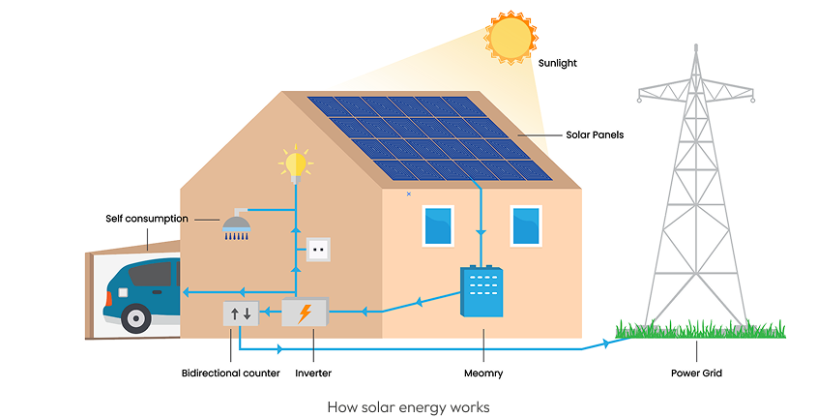

Listening Transcript: Solar Panels and Climate Tech at Monalee
Solar panels, also called photovoltaic (PV) panels, convert sunlight into electricity using semiconductor materials like silicon. This technology has existed since the 1950s, but it became more affordable and efficient in the last two decades thanks to major innovations in materials and production. Today, solar energy is one of the fastest-growing sources of clean electricity worldwide.
The purpose of solar panels is to reduce dependence on fossil fuels by using sunlight an unlimited, renewable source of energy. Solar power helps lower greenhouse gas emissions, reduce electricity costs, and protect the environment.
Monalee is a U.S.-based climate tech company that helps families install solar panels, home batteries, and EV charging stations. What makes Monalee unique is its use of artificial intelligence and machine learning to design solar energy systems faster and more accurately than traditional companies.
Andrés works on the Analytics Team as a Data Engineer. His job is to prepare high-quality datasets that train the ML models used in solar design. He also supervises virtual assistants who label and annotate images to help improve the AI’s accuracy. These models help Monalee create 3D roof layouts, optimize panel placement, and estimate how much sunlight a house will receive.
Another part of Andrés’ work is monitoring system performance and identifying technical issues. For example, if the AI misplaces a panel or skips a rooftop entirely, Andrés helps analyze the problem and propose solutions.
His work is essential for delivering smarter, faster, and more reliable clean energy to homeowners. By improving the data and design process, he helps Monalee expand solar adoption, one house at a time.

Comprehension Questions
Part 1 – Multiple Choice
- When did solar panels first appear?
a) 1930s
b) 1950s
c) 1980s
d) 2000s
- What is the main goal of using solar energy?
a) Increase fossil fuel use
b) Lower taxes
c) Reduce greenhouse gas emissions
d) Replace water systems
- What is unique about Monalee’s approach?
a) It builds solar panels from scratch
b) It uses AI for solar design
c) It only installs batteries
d) It only works in Colombia
- What does Andrés help improve at Monalee?
a) Customer service platforms
b) AI model accuracy and data quality
c) Energy billing systems
d) Legal contracts for homeowners
- What can the AI model at Monalee do?
a) Sell electricity
b) Predict earthquakes
c) Create roof layouts and estimate sunlight
d) Detect noise in urban areas
Part 2 – True or False
- Solar panels were invented in the 2000s.
- Sunlight is a renewable energy source.
- Monalee uses machine learning in solar design.
- Andrés works with customer complaints.
- Virtual assistants help label training data.
Part 3 – Open Questions
- How do solar panels work?
- What role does AI play in solar system design?
- What are some benefits of using solar energy?
- Why is high-quality data important for Monalee’s AI?
- How does your work make clean energy more accessible?

Answer Key
Multiple Choice
- b) 1950s
- c) Reduce greenhouse gas emissions
- b) It uses AI for solar design
- b) AI model accuracy and data quality
- c) Create roof layouts and estimate sunlight
True or False
6. False
7. True
8. True
9. False
10. True
Sample Open Answers
11. They convert sunlight into electricity using silicon-based cells.
12. AI helps design systems faster and optimize placement.
13. Clean, renewable, reduces emissions, lowers bills.
14. Accurate data leads to better predictions and designs.
15. It helps families get smart, cost-effective solar solutions.

